SAT Prep: Close reading
Literature passage: As you read a piece of literature, think about some key elements of fiction:
Characterization, mood, conflict, irony, setting, plot (especially a climax or turning point), other lit elements

Note the contextthis helps you to know whether you are reading fiction or nonfiction. Here, it gives info about setting (both time and place). That can help your understanding of the passage!

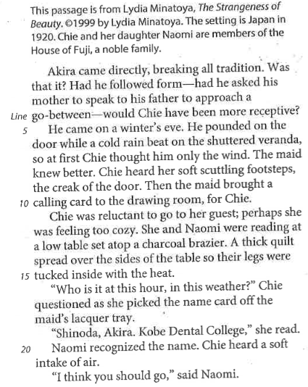
Plot: Review lines 1 through 22. Paraphrase the plot; what has just happened?
Detail (characterization): What does that reveal about Akira?

Detail (characterization): How does Akira treat Chie? Why?

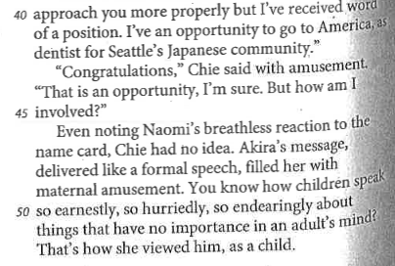
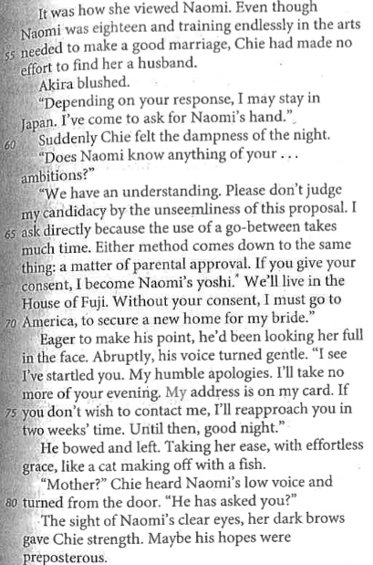
Detail (plot/characterization): How/why is that line significant?
Detail (plot/characterization): Why is Akira so concerned about time?
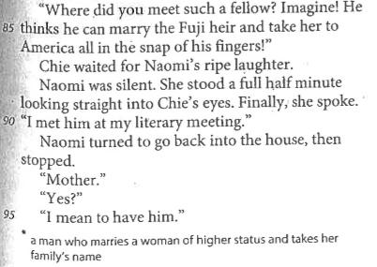
Foreshadow: Return to the passage and highlight in blue one detail that hints at Naomi’s interest in making Akira her husband.

